

**A Project Report On,**

**“Fabrication of Titanium Oxide Photo Anode by Doctor Blade Method and its Application in Dye Sensitized Solar Cell”**

**For the partial fulfillment of the Degree of Master of Science (M.Sc.)**

**(2016-2017)**

**In Physics**

**At Department of Physics,**

**Savitribai Phule Pune University ,Pune**

**By**

**JADHEKAR VIDYA DINKAR**

**PRN No. 2014PO35**

**Department of Physics,**

**Savitribai Phule University of Pune.**

**UNDER THE GUIDANCE OF**

**Dr .HABIB M PATHAN**

**Department of Physics**

**ACKNOWLEDGEMENT**

It gives a great pleasure to express my deep sense of gratitude towards my esteemed guide **Dr. H.M Pathan, Assistant Professor**, Department of Physics, Savitribai Phule Pune University, for his able guidance, encouragement and co-operation extended to me during this project work.

I am especially thankful to **Prof. Dr. Anjali Kshirsagar**, Head of the Department, Department of Physics, Savitribai Phule Pune University for extending all the departmental facilities to carry out my project.

I have great pleasure in extending my sincere thanks to, Ms. Chaitali Jagtap Ms. Shubhangi Khadtare & Ms. Pooja Magar, Ms. Fouzia Shaikh, Ms. Saima Sayyed, Mr. Ravi Ingle, Mr. Vishal Kadam, Mr. Abhijeet Supekar who have created friendly and cheerful atmosphere in the lab and encouraged me every time. Without their help, I would have never been able to complete this project successfully.

I am thankful to all my M.Sc. class friends for supporting and encouraging me throughout the project.

Ms. Jadhekar Vidya Dinkar

(M.Sc. PHYSICS)

**CONTENTS**

**Chapter.1: INTRODUCTION**

* Introduction
* Three generations of solar cell
* Why TiO2 is interesting??
* Properties of TiO2.
* Dye sensitized Solar Cell
* Operation of DSSC
* Advantaged & Disadvantages.
* Motivation and Scope.

**Chapter.2: Experimentation and Characterization**

* Synthesis
* TiO2 photo anode preparation
* Preparation of Dye.
* Doctor Blade Method.
* Device Making
* Characterization techniques
* X-ray diffraction
* Uv-Visible Spectroscopy
* Scanning Electron Microscopy
* Solar cell and IV curves

**Chapter.3: Results and Discussions**

* Structural Properties: X-Ray Diffraction
* Optical study
* Surface Morphology by Scanning Electron Microscopy
* Optical Studies

**Preface**

Now a day’s importance of Nanotechnology and thin films is growing because of its advantages in almost all fields. Nanoparticles, Nanotubes are changing today’s technology because of their size dependent properties. Various kinds of Nanoparticles like metal, semiconductor & oxides play important role in Nanotechnology.

The importance of TiO2 Nanoparticles has been recognized in a number of applications such as ceramics, catalysts, solar cells, pigments and photonic crystals. For optical applications, Titanium particles are particularly interested due to their high refractive index. Because of technological importance of Titaniaparticles, different approaches of their synthesis have been developed. Out of this the synthesis procedure used here is doctor blade method. The first chapter includes the general information about thin film technology. Generations of Solar cells.Then the some information about self assembly. Also the crystal structure of titanium oxide particles, application of Titania & the synthesis procedure used here is given.

The second chapter gives actual synthesis procedure used for the titanium oxides. The next section gives working principles and experimental parameters used for different characterization techniques like Scanning Electron Microscope (SEM), UV-Visible absorption spectroscopy and X-Ray Diffraction method (XRD).The third chapter gives the result obtained like UV; SEM & XRD pattern of the titanium oxides.

***Chapter 1***

***INTRODUCTION***

**Chapter 1.**

* **Introduction:-**

Solar cell technology is used to convert solar energy into electrical energy which can be used to power electrical devices. Solar cells are already used to supplement or replace dependence on conventional energy sources in few homes and businesses. There is the potential, however, for further development and wider acceptance of solar cell use to be the answer to the growing energy situation. The solar energy is distributed broadly in the electromagnetic (EM) spectrum covering UV, visible and infrared (IR) regions.

The conversion of this EM energy to other useful forms (mainly electrical, thermal or chemical) helps us to utilize this abundant solar resource to our advantage. Solar photovoltaic (PV), solar thermal and thermo-photovoltaic (TPV) converters are designed precisely with the aim of fulfilling our everyday energy needs.

Amongst the solar energy converters, solar photovoltaics have seen significant development in terrestrial applications over the past few decades owing to increasing oil prices, global awareness of climate change, reducing carbon footprint and the goal of making electricity affordable to every household. Few decades earlier, the existence of new class of material whose dimension lie in the range of 1 to 100 nm were understood. The material of this size has different properties than that of their bulk counterpart. Bulk solids such as metal and semiconductor contain atoms and molecule, yet the properties of solid can be totally different from their constituent atom and molecule.

Semiconductor nanoparticles form different class of material which is intermediate between molecule and bulk. Hence ,these exhibit properties ,which are quite different than that of molecule as well as bulk solid .the physical and chemical properties of material is greatly depend upon its size and this is true for almost all class of materials i.e. metal,semiconductor,insulators.

Photo-electrochemical solar cells (PSCs),consisting of a photo-electrode, a redox electrolyte, and a counter electrode, have been studied extensively .Several semiconductor materials ,including single-crystal, polycrystal forms of n and p-Si, n-and p-GaAs etc. have been used as photo electrodes. These materials when used with suitable redox electrolyte ,can produce solar light to current conversion efficiency of approximately 10%.However under irradiation, photo corrosion of the electrode in the electrolyte solution is frequently occurs ,resulting in poor stability of cell ,so effort have been made worldwide to develop more stable PSCs.

Oxide semiconductors materials have good stability under irradiation in solution. However, stable oxide semiconductor cannot absorb visible light because they have relatively wide band gaps. Sensitization of wide band gap oxide semiconductor material, such as TiO2, ZnO and SnO2,with photosensitizers, such as organic dyes, that can absorb visible light has been extensively studied in relation to the development of photography technology since the late nineteenth century.

A dye-sensitized solar cell a low-cost [solar cell](https://en.wikipedia.org/wiki/Solar_cell) belonging to the group of [thin film solar cells](https://en.wikipedia.org/wiki/Thin_film_solar_cell). It is based on a [semiconductor](https://en.wikipedia.org/wiki/Semiconductor) formed between a photo-sensitized anode and an [electrolyte](https://en.wikipedia.org/wiki/Electrolyte), a [photo electrochemical](https://en.wikipedia.org/wiki/Photoelectrochemical_cells) system.

In sensitization process, photosensitizer absorbed onto the semiconductor surface absorbs visible light and excited electron is injected into the conduction band of semiconductor electrodes. Dye sensitized oxide semiconductor photoelectrodes have been used for PSCs. The DSC is a photo-electro-chemical device. In its operation it involves a photon, an electron and a chemical reaction. The operation of DSC is considered similar to that of a photosynthesis process.

Due to this reason the operation of the DSC is fundamentally different than that of a crystalline Si-based solar cell. In this case the function of light absorption and charge transport is done by two different materials, unlike in other semiconductor based cells where both of these jobs is done by the same material. This allows choice and configuration of materials.

* **Three generations of Solar Cells:-**
* **First generation:-**

The first generation of solar cell i.e., photovoltaic cells consists of a large area ,single layer p-n junction diode ,which is capable of generating useable electrical energy from light sources with the wavelength of sunlight .These cells are typically made using a silicon wafer.

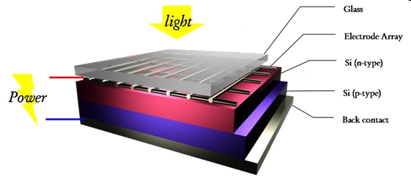

**Figure 1:** First generation of Solar Cells

First generation photovoltaic cells (also known as silicon wafer –based solar cells) are the dominant technology in the commercial production of solar cell, accounting for more than 86% of the solar cell market.

* **Second Generation:-**

The second generation of photovoltaic material is based o the use of thin film deposits of semiconductor. These devices were initially designed to be high efficiency, multiple junction photovoltaic cells.later,the advantage of using a thin film of material was noted, reducing the mass of material required for cell design.this contributed to a prediction of greatly reduced costs for thin film solar cells.

The second generation solar cells can also be produced so they are flexible to some degree. However, as the production of second generation solar cells still include vacuum processes and high temperature treatments, there is still a large energy consumption associated with the production of these solar cells. Further, the second generation solar cells are based on scarce elements and this is a limiting factor in the price.

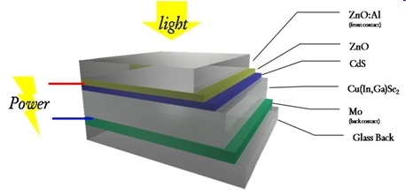

**Figure 2:** Second Generation of Solar Cells

Currently there are different semiconductor materials under investigation, such as amorphous silicon, polycrystalline silicon, micro–crystalline silicon ,cadmium telluride, copper indium sulfide. Typically the efficiencies of thin film solar cell are lower compared with silicon solar cells, but manufacturing costs are also lower, so that a lower price of electrical output can be achieved. another advantage of the reduced mass is that less support is needed when placing panel on rooftops and it allows fitting panel s on light materials or flexible materials, even flexible.

* **Third Generation:-**

Third generation photovoltaic’s are very different from the other two ,broadly defined as semiconductor devices which do not rely on a traditional p-n junction to separate photo generated charge carriers. Third generation solar cells uses organic materials such as small molecules or polymers. Thus, polymer solar cells are a sub category of organic solar cells.

The third generation also covers expensive high performance experimental multi-junction solar cells which hold the world record in solar cell performance. This type has only to some extent a commercial application because of the very high production price.

A new class of thin film solar cells currently under investigation is perovskite solar cells and show huge potential with record efficiencies beyond 20% on very small area. Polymer solar cells or plastic solar cells, on the other hand, offer several advantages such as a simple, quick and inexpensive large-scale production and use of materials that are readily available and potentially inexpensive.

Polymer solar cells can be fabricated with well-known industrial roll-to-roll (R2R) technologies that can be compared to the printing of newspapers. Although the performance and stability of third generation solar cells is still limited compared to first and second generation solar cells, they have great potential and are already commercialized, e.g. by [infinityPV.com](http://www.infinitypv.com/).

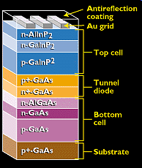

**Figure 3:** Third Generation of Solar Cells

These new devices include photo electrochemical cells .Polymer solar cells , and nanocrystal solar cells. Companies working on third generation photovoltaic includes *xsuns,konarka technologies,Inc.,Nanosolar and nano sys.*Research is also being done in this area by USA’s National Renewable Energy Labortary.

* **Why TiO2 is interesting??**
* Titanium oxide is direct, wide band gap semiconductor material having band gap 3.2 eV.
* TiO2 have high refractive index, and brightness.
* The second respect in which oxide semiconductors differ from silicon and germanium is the separation of cations by the oxide ions
* It has strong UV light absorbing capabilities and its resistance to discolouration under [ultraviolet](https://en.wikipedia.org/wiki/Ultraviolet) light.
* TiO2 is chemically stable element.
* Electron mobility of TiO2 is high.
* TiO2 is grown on inexpensive substrate such as glass at relatively low temperature.
* Nanostructures such as nanowires and nanorods have been demonstrated.
* **Widely used:*-***
* In medical purpose.(colds,antiseptics,sunscreen lotions etc)
* It is used as a pigment for paints.
* Used in electronics in laser diodes,LED’s etc.
* TiO2 has been widely used in polycrystalline form for over a hundred years in a wide range of applications. Facial powder, ointments,catalysts,lubricant additives as paint pigmentation,etc.
* **Properties of TiO2**
* **Physical properties of TiO2**

Titanium oxide nanoparticles appear in the form of black hexagonal crystals. The table below provides the physical properties of these nanoparticles.

**Table 1**: Physical properties of TiO2

|  |  |  |
| --- | --- | --- |
| **Properties** | **Metric** | **Imperial** |
| Density | 4.23 g/cm3 | 0.152 lb/in3 |
| Molar Mass | 79.9378 g/mol |  |

* **Chemical Properties of TiO2**

**Table 2:**The following tables list the chemical properties of titanium oxide.

|  |  |
| --- | --- |
| **Chemical Data** | |
| Chemical symbol | TiO2 |
| CAS No | 1317-80-2 |
| Group | Titanium 4 Oxygen 16 |
| Electronic configuration | Titanium [Ar] 3d2 4s2 Oxygen [He] 2s2 2p4 |

* **Thermal properties of titanium dioxide:-**

**Table 3:** The thermal properties of titanium oxide nanoparticles are as below.

|  |  |  |
| --- | --- | --- |
| **Properties** | **Metric** | **Imperial** |
| Melting Point | 1,843° C | 3,349° F |
| Boiling Point | 2,972° C | 5,382° F |

* **Dye sensitized solar cells (DSSC):-**

**Structure of dye sensitized solar cell:-**

The main parts of single junction dye sensitized solar cell are illustrated schematically in Figure. The cell is composed of four elements, namely, the transparent conducting and counter conducting electrodes, the nanostructure wide band gap semiconducting layer, the dye molecules (sensitizer), and the electrolyte.

The transparent conducting electrode and counter-electrode are coated with a thin conductive and transparent film .

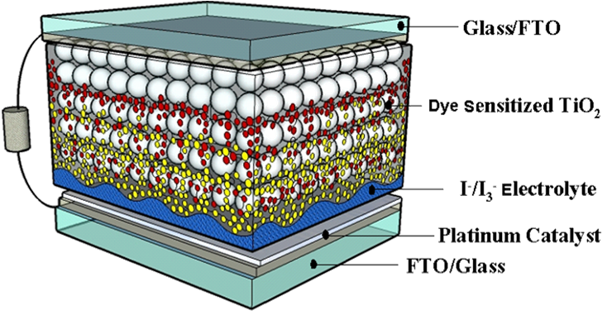

**Figure 4:** Schematic of the structure of the dye sensitized solar cell

First dye-sensitized solar cell (DSC) concept is presented in 1991, since then a lot of interest has been aroused in this technology. The DSC can be considered as thin film solar cell devices. This technology is not yet commercialized but is on the verge of commercialization. The DSC solar cells can be made flexible. It has a good potential for being low cost solar cell technology. This is mainly possible because of the large availability and low cost of the ingredient material as well as due to the low processing temperatures. With this type of concept more than 11 % efficient cells have been demonstrated.

Although, the long term stability of these devices has always been of concern. Normally liquid electrolyte is used, and in long-term operation its leakage is one of the main concerns. Recently it has been shown that similar to Si wafer-based solar cells; the DSC can also operate for as long as 20 years. The DSC is a photo-electro-chemical device. In its operation it involves a photon, an electron and a chemical reaction. The operation of DSC is considered similar to that of a photosynthesis process.

Due to this reason the operation of the DSC is fundamentally different than that of a crystalline Si-based solar cell. In this case the function of light absorption and charge transport is done by two different materials, unlike in other semiconductor based cells where both of these jobs is done by the same material. This allows choice and configuration of materials. In DSC, the light is being absorbed by materials named as dye and the carriers are being transported by wide band gap semiconductor.

* **Operation of dye sensitized solar cells:-**

Similar to any other solar cell a dye-sensitized solar cell also absorb light, generate carriers, transport carriers to the external load at higher voltage and bring back the carrier in the cell at lower voltage. A typical DSC structure used for this purpose is shown in figure 5. The operation of a DSC can be explained using the following steps:

**Step 1:-**

In this step, the absorption of a photon by a dye molecule (S) takes place. After the photon absorption, the dye molecule goes into the excited state, S* ,Within a very short time, of the order of 10-15 s, the electron is given off to the wide band gap semiconductor and the excited dye molecule gets oxidized (loss of electrons) to S+.

This can be put in the form of the following equation,

**S + Photon = S* (excited state) = S+ + e-**

It is required that the point of photon absorption in the dye should be close to the semiconductors (else electron would recombine in the dye).

Due to this, only dye molecule that is in direct contact of the semiconductor can be photoactive. Now, if only one layer of dye is deposited on the flat semiconductor surface, the effective absorption of the photons would be very less.Thus, in order to increase the effective photon absorption, the surface area of semiconductor-dye contact should be increased. This can be obtained when the semiconductor is a porous material.

Normally, wide band gap TiO2 (with 3.2 eV band gap) is used as a semiconductor. It is deposited with screen printing and in order to remove the solvent and binders, sintering at about 450 °C to 550 °C is done. This results in the formation of porous layer of about 75 % to 80 % porosity with average TiO2 particles size of about 20 nm.

The dye molecules can easily penetrate in the pores of TiO2 and get deposited around it. With this morphology of the semiconductor-dye, the effective absorption increases by over 1000 times. Therefore, the nanostructure of TiO2 is very important and plays a role in cell operation.

**Step 2:-**

In this step, the excited electron is given off to the conduction band of semiconductor. A TCO layer is used to collect the electrons from the conduction band. Normally, fluorine doped tin oxide is used for this purpose. The electrons then flow through the external load to the counter electrode, which is also made of the TiO2

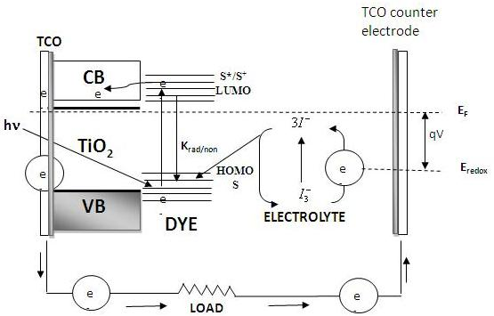

**Figure 6:**Operating Principle of dye-sensitized solar cells

**Step 3:-**

In this step, the oxidized dye molecule S+ is reduced to the original form S by regaining electrons from the organic electrolyte solution. The electrolyte solution contains the iodide (I-)/tri-iodide (I3-) redox system in which the iodide ions are being oxidized to tri-iodide ions. To restore the iodide ions, free electrons at the counter electrode reduce the tri-iodide molecule (which carries positive charge from dye) back to their iodide state.

This step requires catalytic presence of Pt at the electrode. In this way a cycle gets completed. This makes the dye molecules again available for the excitation/oxidation/reduction cycle.

**S+ + 3/2 I- + e- = S + 1/3 I3-**

Thus, in an overall conversion of photon to electricity, no change in the chemical properties of ingredient material occurs and the arrangement can be used for long duration. Solar cell efficiency of more than 11 % has been demonstrated in DSC

* **Advantages:-**

**The DSSC has number of attractive features:**

* It is simple to make using conventional roll printing techniques
* It is semi flexible which offers a verity of uses not applicable to glass based system.
* Most of the materials used are low cost. In practice it has proven difficult to eliminate the number of expensive materials, notably platinum & ruthenium and a liquid electrolyte presents a serious challenge for making a cell suitable for use in all weather.
* DSSCs work even in the low light condition.DSSCs are therefore able to work under cloudy-skies and indirect sunlight, whereas traditional designs would suffer a “cutout” at some lower limit of illumination, when charge carrier mobility is low and recombination becomes a major issue.
* A practical advantage is ,the DSSC share with most thin film technologies is that ,the cells mechanical robustness indirectly leads to higher efficiencies in higher temperature.
* DSSC are normally built with only a thin layer of conductive glass on the front layer, allowing them to radiate away heat much easier & therefore operate at lower internal temperatures.
* **Disadvantages:-**
* The major disadvantages of DSSCs design is the use of electrolyte, which has temperature stability problem.
* At lower temperature the electrolyte can freeze ,ending power production and potentially leading to the physical damage.
* higher temperature causes the liquid to expand, making sealing the panels a serious problem.
* Major drawback is electrolyte solution contain volatile organic compounds, solvents which must be carefully sealed as they are hazardous to health and environment.
* **Eosin y dye:-**

A dye is a [colored](https://en.wikipedia.org/wiki/Color) substance that has an [affinity](https://en.wikipedia.org/wiki/Chemical_affinity) to the [substrate](https://en.wiktionary.org/wiki/substrate) to which it is being applied. The dye is generally applied in an [aqueous solution](https://en.wikipedia.org/wiki/Aqueous_solution), and may require a [mordant](https://en.wikipedia.org/wiki/Mordant) to improve the fastness of the dye on the fiber. Both dyes and pigments are colored because they absorb some wavelengths of [light](https://en.wikipedia.org/wiki/Light) more than others. In contrast to dyes, pigments are insoluble and have no affinity for the substrate.

Eosin is a [fluorescent](https://en.wikipedia.org/wiki/Fluorescent) acidic / negative compound that binds to and forms salts with basic, or eosinophilia, compounds containing positive charges (such as proteins that are basic / positive due to the presence of amino acid residues such as [arginine](https://en.wikipedia.org/wiki/Arginine) and [lysine](https://en.wikipedia.org/wiki/Lysine)) and stains them dark red or pink as a result of the actions of [bromine](https://en.wikipedia.org/wiki/Bromine) on [fluorescein](https://en.wikipedia.org/wiki/Fluorescein).

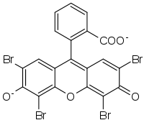

**Figure 7:** structure of Eosin Y

In addition to staining proteins in the [cytoplasm](https://en.wikipedia.org/wiki/Cytoplasm), it can be used to stain collagen and [muscle fibers](https://en.wikipedia.org/wiki/Muscle#Muscular_Composition) for examination under the [microscope](https://en.wikipedia.org/wiki/Microscope). Structures that stain readily with eosin are termed [eosinophilic](https://en.wikipedia.org/wiki/Eosinophilic).

* **Motivation and scope:-**

Semiconductor nanocrystals have been considered as potential candidates in wide range of applications based on their structural and optical properties. There are number of methods and techniques used to synthesis nanoparticles and nanocrystals.amongst these methods, doctor blade is simplest method used to synthesize TiO2 nanocrystals.

* **Our motivation undertaking this project:-**
* To learn simplest easiest “doctor blade “method for preparation of TiO2 nanocrystals.
* To learn and use various characterization techniques such as X-ray diffraction,UV-vis spectroscopy,scanning electron microscope.etc
* To learn working of dye sensitized solar cell.
* And also to study the TiO2 based dye sensitized solar cell.

In the present work we used TiO2 nanopowder.made a TiO2 paste using this nanopowder.then using docter blade method we got TiO2 nanocrystal.and using eosin y dye we made TiO2 based dye sensitized solar cell, studied much of it’s characterization techniques and calculated its efficiency.

***Chapter 2***

***EXPERIMENTAL AND CHARACTERIZATION***

**CHAPTER 2.**

* **Experimental and Characterization:**
* **Synthesis:-**
* **TiO2 Photo anode preparation:-**

**Formation of TiO2 Paste:-**

**Table 4:** Shows the chemicals use for TiO2Photoanode preparation

|  |  |
| --- | --- |
| TiO2 nanopowder | 1gm |
| Ethyl cellulose | 0.6gm |
| Terpineol | 5.44gm |
| Acetyl acetone | 2ml |
| Ethanol | 25ml |

* **TiO2 electrode and cell fabrication:-**

1. Take 1gm of TiO2 powder, add few ml of ethanol (20 ml) to it add grind it for some time using mortar and pestle (for ~30 min). Transfer this Suspension into a clean beaker and sonicate it for 30 min.
2. Take 0.6 gm of ethyl cellulose and grind it for 30 min like in previous step and add few ml of ethanol (20 ml) to it, make a paste by grinding it for 30 min and sonicate it for 30 min. After sonication add this to the prepared suspension in the paste of TiO2.
3. Ethyl cellulose is introduced into the suspension as a pore filling agent or resin and also to increase the viscosity of paste, use of ethyl cellulose is advantageous as it result in greater surface area of Photo anode than when poly ethyl cellulose is used.
4. Now sonicate this in a 10ml beaker for 3 hours, after adding 5.44gm of Terpineol dropwise, Terpineol used here in the present method, is a non-ionic surfactant, which hardly charges the surface of the particle and so the surface of the particle is more or less neutral.
5. After 3 hours of sonication, a fine paste of TiO2 is obtained which is kept in the incubator to make it more viscous and free of particulates.
6. Doctor blading of this paste results in transparent photo electrode of TiO2, Annealing these films at 450⁰C for 1hour gives porous, transparent and uniform Titania photo electrode.

* **Preparation of Dye:-**

Eosin-Y, ethanol were used in preparation of Dye. 0.3mM of Eosin-Y was mixed with ethanol. The prepared solution was kept for stirring until Eosin -Y was dissolved in ethanol.

* **Preparation of Electrolyte:-**

Chemicals such as Potassium Iodide (KI), Iodine (I2) and Butyl Pyridine were used in preparation of Electrolyte. 1.5 M of KI in water, 0.29 M of I2 in Acetonitrile and 1.5 M Butyl Pyridine in Acetonitrile. Three solutions were mixed together and kept for stirring for 4-5 hours.

* **Doctor Blade Method:-**

TiO2 paste was applied on the conducting substrate by doctor blading using scotch tape as a frame and spacer. this process is repeated three times in order to achieve thickness of the order of few micron. Then we annealed these films at 4500c for 1 hour.



**Figure 8:** Film preparation by Doctor Blade Method

* **Device Making:-**

A freshly preparedTiO2 film were kept in eosin y dye solution .the tio2 film were kept in ml solution of Eosin -Y.the sensitization time was more than 6 hrs. After dye loading,the films were rinsed in ethanal to remove excess dye.the fabricated device were characterized for their photovoltaic performance for different intensity of light.





**Figure 9 :** Device of Dye sensitized solar cell.

* **Characterization Technique**

Before using the films in applications, one has to characterize the films to achieve optimum performance of the films prepared. The properties of the films and aspects of growth mechanism can be well understood by the characterization of the films. In this section various characterization tools which were used in the experiment such as, X-ray diffractometer (XRD), Scanning Electron Microscope (SEM), UV -Vis-NIR, I-V measurement set up are shortly described.

* **X-ray Diffraction:**

X-ray diffraction is widely used technique for the structural characterization of the sample. X-ray diffraction patterns were recorded using Cu-Kα radiation (1.54A0). It is useful for identifying crystal structure of materials.

This technique is also useful for estimating the phase of the material as well as grain size by using Scherer’s formula. Nonmaterial’s exhibit crystalline phases, which may be different for their bulk counterpart. Thus crystalline phases existing in the material can be identified by comparing structural features with standard JCPDS data.

X-rays are mainly used in this technique because their wavelength is comparable to interatomic distance of the atom of the material. X-rays are electromagnetic radiations having shorter wavelength (0.5Å - 2.5Å) than UV radiation larger than gamma radiation X-rays are scattered by atom of material to give information about their arrangement inthe solid.

* **Braggs Law:-**

When a beam of x-rays strikes the crystal in which the layers of the atoms are separated by distance ‘d’, then maximum intensity of x-ray will occur only when the rays interfere constructively. That is the path difference between two consecutive rays must be equal to integral multiple of wavelength. Waves are reflected from parallel planes of atoms in the crystal with each plane .Reflecting only a very small fraction of radiation like lightly silvered mirror.The diffracted beams are formed when the reflections from parallel planes of atoms interfere constructively.

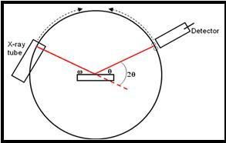

**Figure 10**:X-ray Diffractometer

Therefore Bragg’s law,

2dsin θ = n λ

where n =is the order of diffraction ,

λ= is wavelength of X-rays used,

d= is the interplaner spacing and

θ =is Braggs angle of diffraction.

This condition implies that the scattered beam will interfere constructively and will give sharp intensity diffracted peaks only when the path difference between all the scattered beams is integral multiple of wavelength and the wavelength is the order of interplaner spacing.

In the normal θ -2θ scan mode, abeam of monochromatic X-rays is made incident on sample, making an angle theta with the sample surface. The detector motion is coupled with that of X-ray source, so that it is always kept at a position, which makes an angle theta with the incident radiation of the X-ray beam. Different crystals in the polycrystalline sample will have different orientation.

Certain orientations for which Braggs condition is satisfied, will give us diffraction pattern. The spectrum is recorded as a plot of intensity of X-rays, detected by the detector, versus 2θ. From this plot the interplaner spacing d can be found using the Braggs condition.

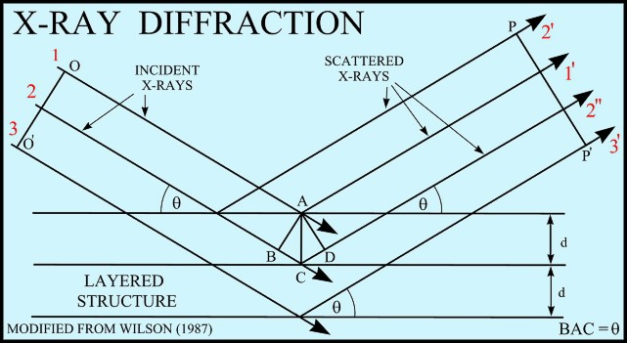

**Figure 11:**X- ray diffraction

**Table 5**: The specifications regarding the θ-2θ scan for X-ray diffraction

|  |  |
| --- | --- |
| X-ray target | Copper |
| X-ray filter | Nickel |
| Wavelength | 1.542Å |
| Scan range | 10-90 |
| Scan period | 0.10/second |

By comparing the interplaner spacing and the intensity calculated from x-ray diffract grams with the standard ASTM data; one can obtain the knowledge about the different phases present in the sample.

Crystalline size causes the peak broadening. The known Scherer equation explains peak broadening in terms of beam incident, beam divergence, which makes it possible to satisfy the Braggs condition for non adjacent diffracting planes. Once instrument effect has been excluded, the crystalline size been easily calculated with Full Width Half Maxima of most intense peak.

The Sherrers formula,

t=o.9 λ / β cosθ

Where,

t - Grain size in (Å)

λ-Wavelength of incident radiation in (Å) (Cu k =1.5Å)

β- Full width half maxima (in radians)

θ -Braggs angle (in degrees)

* **Uv-Visible Absorption Spectroscopy:-**

Optical absorption spectroscopy is the one of the simplest technique to determine the formation of nanoparticles. Some metal nanoparticles show an absorption bond in the visible range of electromagnetic spectrum, origin of which is due to the resonance between the frequency of oscillation of conduction electrons and the incident electromagnetic radiations as explained.

In case of semiconductor or oxides nanoparticles such as TiO2 absorption in UV to Visible range can occur with characteristic absorption edge. In semiconductor, when photon of energy hν equal to the band gap or difference between the highest occupied energy level and lowest unoccupied energy level of electron is incident, transition of electron from lower to higher level takes place. This result in sharp absorption peak, position of which depend on the particle size. In our case absorption spectra were recorded by dispersing nanoparticle in suitable solvent.

According to Lambert-Beer law, the absorbance of solution increases as attenuation of a beam increases. Absorbance is directly proportional to the path length and concentration of absorbing species.

A=E b c,

where

E = absorption coefficient,

c =concentration of material in mole/lit and

b = path length in cm.

Thus absorption of photons after passing through a material can be expressed as

A=log (P0/P)

Where,

P0 = radiant power of incident radiation &

P = radiant power after passing through sample.

Absorption spectra were recorded using a UV absorption spectrometer. Schematic diagram of for typical absorption setup is shown in fig.12.It consist of deuterium lamp(source of UV light) and tungsten halide lamp (source of visible light) as source of electromagnetic radiation from 200 to 3200 nm.Deuterium lamp is operated under low pressure (~0.2 to 0.5 torr) and low voltage (~40 V dc).Tungsten iodide lamp consist of a tungsten filament, which is heated by passing electric current. Filament is coiled to increase its emissivity, and efficiency.

The filament is enclosed in sealed bulb filled with an inert gas such as iodine. The lifetime of this lamp is doubled than that of ordinary lamp. To isolate narrow band of wavelengths filters and monochromators are used.

To minimize the error in the measurement double beam spectrometer is used. A single beam from the source is divided into two beams of equal intensities, which fall on sample as well as reference. The contribution from is nullified in this way and signal from the sample is recorded. The output signal is detected using a photomultiplier tube and passed to the computer, which records the spectrum.

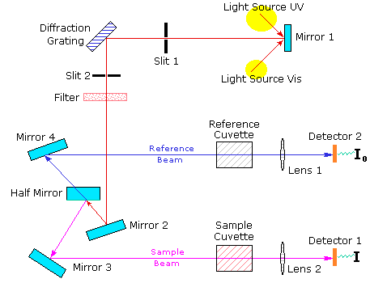

**Figure.12 :** The schematic of UV Visible spectrometer

* **Scanning Electron Microscopy & Energy Dispersive spectroscopy:-**

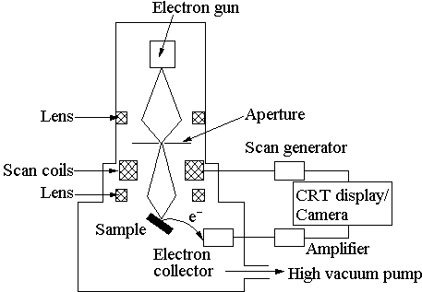

**Figure 15:**Schematic diagram of Scanning Electron Microscopy

In an electron microscope, the electron beam can be focused to a very small spot size using electrostatic or magnetic lenses. Usually the electrostatic lenses are used for an SEM. The fine beam scanned or restarted on the sample surface using scan generator & back scattered electrons are collected by an appropriate detector .Signal from scan generator along with amplified signal from the electron collector generates the image of sample surface. In order to avoid the oxidation & contamination of filaments as well as reduce the collisions between air molecules & electrons, filament & sample have to be housed in a vacuum chamber. Usually vacuum 10-5 torr or better is necessary for a normal operation of scanning electron microscope. No sample preparation is necessary.

Electrons are accelerated as usual in a chamber through a thin foil or aperture so that a large pressure difference can be maintained. In the primary detection mode secondary electro imaging, the SEM can produce a very high resolution image of sample surface, revealing details about 1 to 5 nm in size.Due to the way these image are created, SEM micrograph have a very large depth of focus yielding a characteristics three dimensional appearance useful for understanding the surface structure of a sample. The great depth of field & the wide range of magnifications (commonly about 25 times to 250,000) are available in the most common imaging mode for specimen in the SEM. Characteristic X ray are the second most common imaging mode for an SEM.

One disadvantage of electron microscopes is that insulating samples cannot be analyze directly as they get charge due to incident electrons and images become blue/faulty. Therefore insulating solids are coated with a very thin metal film like gold or platinum (<10nm) making them conducting without altering any essential details of the sample. The metal film is usually sputter coated on the sample to be investigating prior to the introduction into the electron microscope. This enables even biological sample to be analyzed using an electron microscope. Electron microscope can also be used to obtain the composition of sample using a coupled technique by energy dispersive analysis of X-rays (EDAX). When intensities of such characteristic X-rays are compared, one can obtain the composition analysis of the sample under investigation .

* **Solar cells and IV curve:-**
* **I-V characteristics of solar cell:-**

The figure shows ideal solar cell characteristic curve under dark and illuminated conditions. The term at the base of the curve is open circuit voltage, VOC. For Si solar cell the load resistance is extremely (open circuit) high and the current is minimum (almost zero). If the load resistance is lowered slowly, there will be small decrease in the voltage but the current increases sharply. This situation is continue to the point Pmax on the curve. A further decrease in the load resistance, there is no significance change in current but the voltage drops drastically to zero.

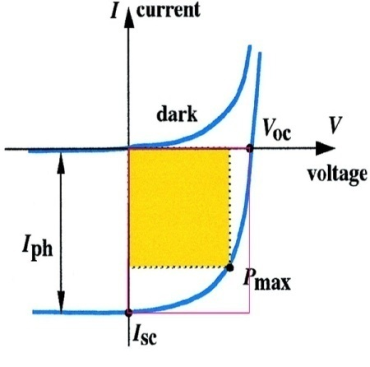

**Figure.16:**IV characteristics of solar cell

When the resistance is lowered to zero the circuit is considered to be open. This point is Isc or short circuit current. At this point voltage is zero. Due to illumination, the light generated current IL superimposed over the normal rectifying current. Hence, the illuminated curve is in fourth quadrant..Since the power from the solar cell is extracted from this quadrant it is also called power quadrant.Behavior of solar cell under the illuminated condition can characterize by three parameters.

**1) Open circuit voltage (VOC):-**

The open circuit voltage is defined as the output voltage from the solar cell when the load resistance is much larger than the device impedance. This is the voltage obtained from a solar cell when no current is flowing through the load resistance. It is the maximum possible voltage.

**2) Short Circuit current(Isc):-**

Short circuit current is the output current from a solar cell when the load resistance is much smaller than the device impedance. It is the maximum possible current.

**3) Fill Factor (FF):-**

The fill factor is defined as the ratio of maximum power that can be obtained from the solar cell to its ideal power.

i.e Fill Factor (FF) =Maximum power/ ideal power

=(Vm*Im)/(Voc*Isc)

It is also known as curve factor. It indicates how well junction is formed in the cell and how low series resistance has been made

The power produced by the solar cell is the result of it’s voltage and current.There is simple equation that act as a basic indicator of a solar module’s performance.

Power(P) =Current(I) * voltage(V)

P = IV

Generation and usage are both measured in watt of power.for example, if you were to turn on a 60 watt light bulb and run it for one hour, you would have used energy for one hour in order to negate your power usage. As the power equation shows, anything that happens to the current or voltage of a dc circuit directly affect the power.IV curve and therefore an accurate way to show the relationship of characteristics of a solar panel and the effect that varying influences have on the final power output of a module, for example decreasing voltage as a module heats up.

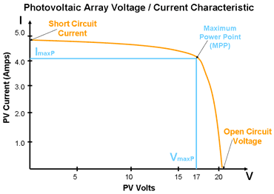

**Figure.17:**IV characterstics of solar cell

* **Factors that affect the performance of solar cell:-**
* **Temperature:-**

Variation of characteristics with temperature. As the temperature of solar cell increases, due to environmental changes or energy production, the open circuit voltage (voc) decreases,directly affecting the power output of the cell.(Power = I*V).temperature also marginally increases the current as the cell’s temperature increases although this causes little change to the Power.

Due to this factor, the design of the system must take into account the temperature coefficient.This involves a calculations that compare the expected average cell temperature,taking into consideration is the installation and surrounding environment against the standard test condition(STC) that were used to calculate the panels output.

For example, if a solar system with a rated output of 265 voc based on an ambient temperature of 250C is installed in an alpine region where the temperature drops below 00C during winter due to the cold temperature and crisp clear skies, the solar panel are capable of producing a much greater voltage than listed. This can cause faults due to inverter(if not sized correctly)to drop out on overvoltage ,meaning that no production can be utilized.

* **Irradiance:-**

Variation of characteristics with irradiance. Lack of sunlight results in low current and voltage.any variance in irradiance in irradiance result in variance in short circuit current.(Isc).the open circuit voltage remains the same,incrasing slightly with higher irradiance.

As irradiance drops the panel’s Isc drops, resulting in reduced power of a module. Due to deflection, irradiance never remains constant, therefore the power output of the module cannot remains constant and varies dramatically throughout the day.

* **Efficiency:-**

The efficiency of solar cell dependent on number of factors and it’s performance can vary greatly depending on it’s location.Solar panel works best in summer,as there is mo1re sunlight for the cells to convert into energy.the main concern of solar efficiency is that not all of the sun’s energy is utilized and generated into electricity.efficiency is the ratio between the amount of sunlight available to the cells to utilized and the actual power generated by the solar cells.solar cells are not 100% efficient.

Losses can occurs if the energy is too weak to eject an electron from its shell. the energy can be resisted by the cellor the internal circuit or be absorbed away from the junction resulting in no energy and excess heat. the total loss of energy is around 82%,leaving the average efficiency of commercial solar cell at about 14-17%With the new technologies scientists are working towords achieving the most efficient solar cell that can utilized more than the current 17% energy of sun .research scientists have managed to achieve 24% efficiency in laboratory.

* **Fill factor**

The power produced by the cell (in watts) is represented by the curve in graph. At the Isc and Voc.Points,the power will be zero. The fill factor is the parameter for evaluating the performance of a cell.It is a ratio of a cell’s actual obtainable power to it’s therotical power.

***Chapter 3***

***RESULT AND DISCUSSION***

**Chapter 3**

* **Result and Discussion:-**

In order to study the structural properties of TiO2 based DSSC, we have used materials characterization techniques such as X-ray Diffraction (XRD),UV-Vis spectroscopy,etc.The results obtained from these characterization techniques are discussed below.

* **XRD analysis Data:-**

**Table 5:**for analysis of XRD

|  |  |  |  |  |  |  |
| --- | --- | --- | --- | --- | --- | --- |
| 2θ(degree) | Θ | ΘB(radians) | Β(degree) | Β×103  (radians) | t×10-8(m) | hkl |
| 25.30 | 12.65 | 0.220 | 0.125 | 2.18 | 6.56 | <101> |
| 27.43 | 13.69 | 0.238 | 0.11 | 1.91 | 7.41 | <110> |
| 36.08 | 18.02 | 0.314 | 0.095 | 1.65 | 8.58 | <101> |
| 41.26 | 20.63 | 0.360 | 0.13 | 2.26 | 6.26 | <111> |
| 47.99 | 23.99 | 0.418 | 0.13 | 2.26 | 6.26 | <200> |
| 54.32 | 27.49 | 0.479 | 0.125 | 2.18 | 6.49 | <211> |
| 56.60 | 29.30 | 0.511 | 0.125 | 2.18 | 6.49 | <220> |



**Figure.18:** X-Ray diffraction pattern

X-ray diffraction spectrum of the TiO2 based DSSC as shown.in fig.The spectrum shows all peaks corresponding to TiO2 only.The diffraction peak indexing was done by comparing observed 2θ values with standard data base(JCPD card no 86-147).The X-ray spectra of TiO2 based Dye Sensitized Solar cell under all experimental conditions shows a set of well defined diffraction peak .These all peaks corresponding to <101>,<110>,<101>,<111>,<200>,<211>,<220> planes having tetragonal crystal structure. And we used Scherer’s formula for calculating the average crystal size.

The above table shows the values of <hkl> planes and corresponding grain size as per Dbey Scherer’s formula. Accordingly we got the grain size of TiO2 nanocrystal.

**Conclusion:**

Therefore as per X-ray analysis the partical size of TiO2 nanoparticle is 85.80nm

* **UV-Visible absorption analysis:-**
* **undoped film of TiO2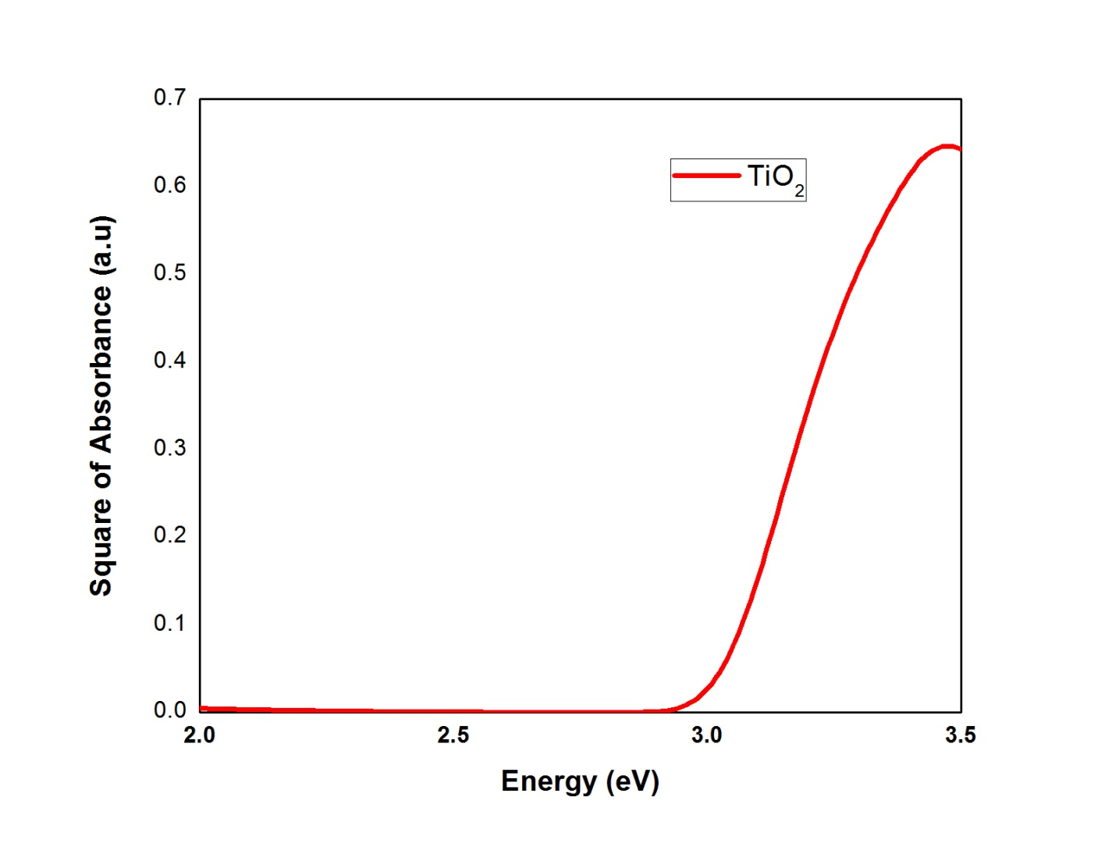 Figure.19**: graph of absorbance square Vs wavelength for TiO2 film
* **For dye doped film, un doped film and eosin Y dye**

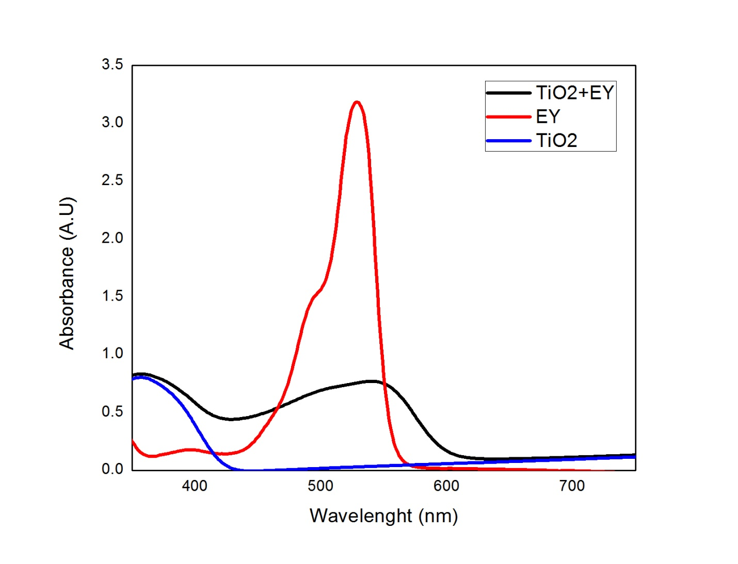 **Figure20:**Graph of absorbance vs. wavelength

**Conclusion: -**Using UV-Visible spectroscopy we founded the band gap of TiO2 as 3.02 eV, which is much close to its original value 3.2eV.

* **Scanning Electron Microscopy:-**

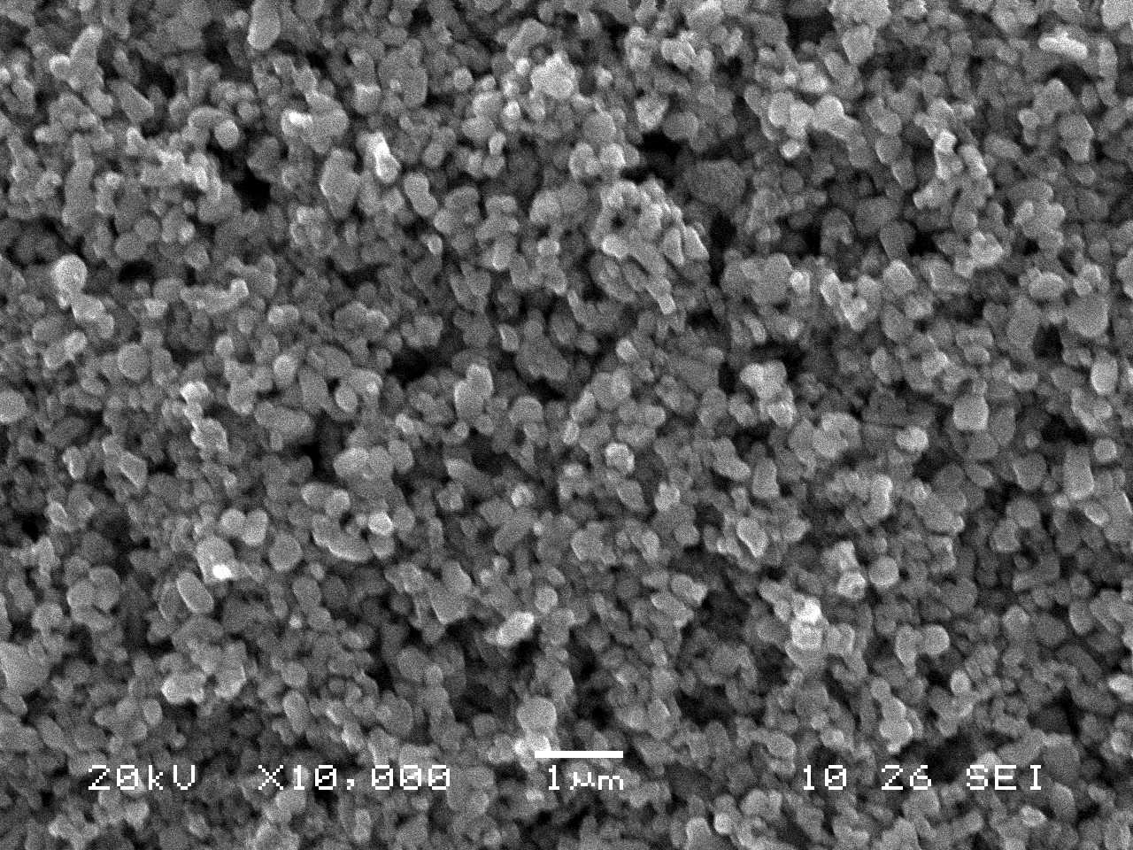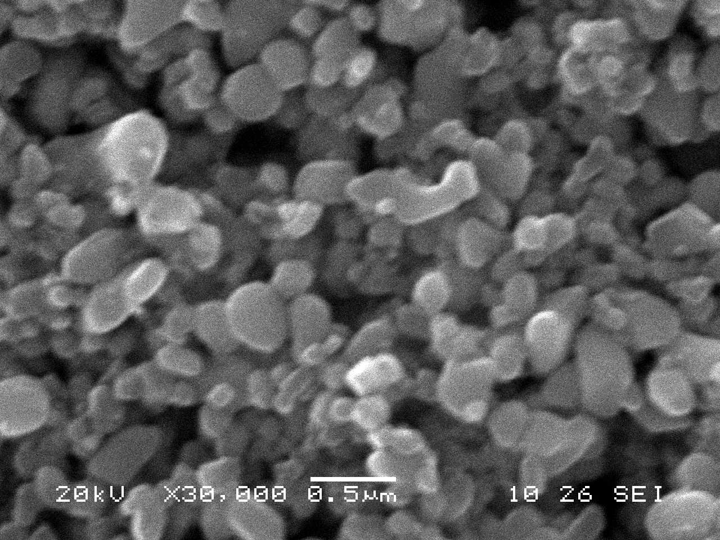

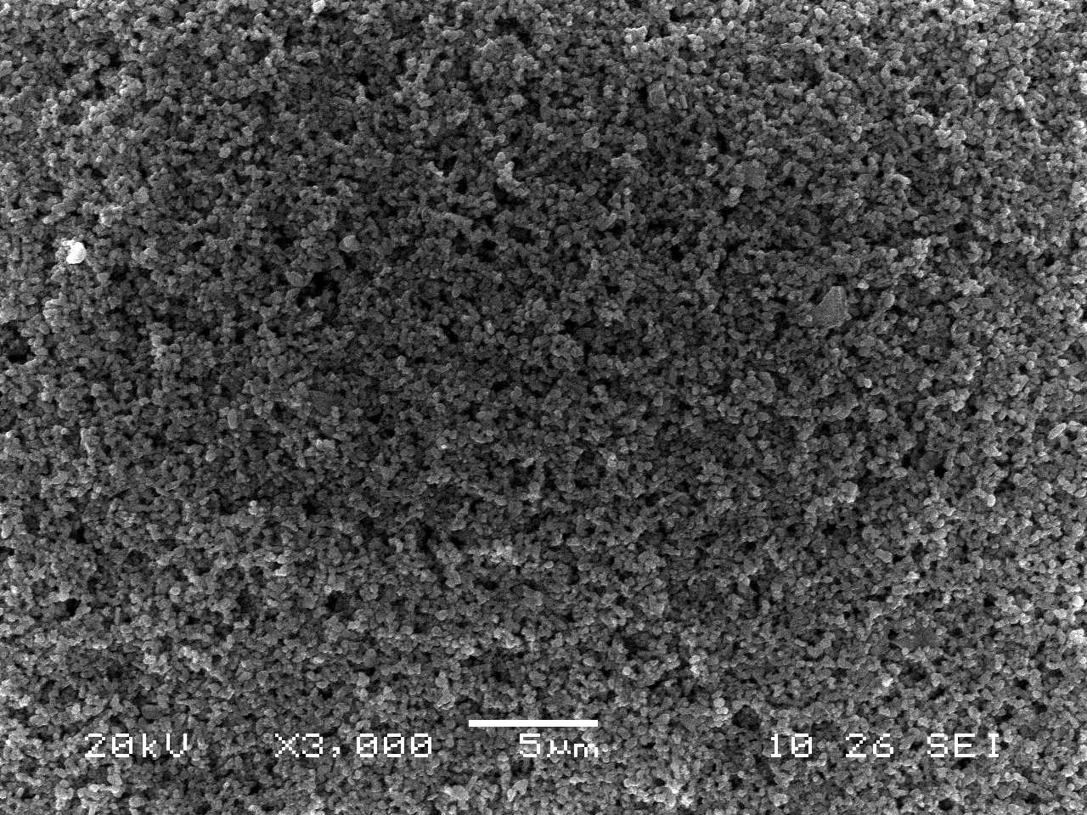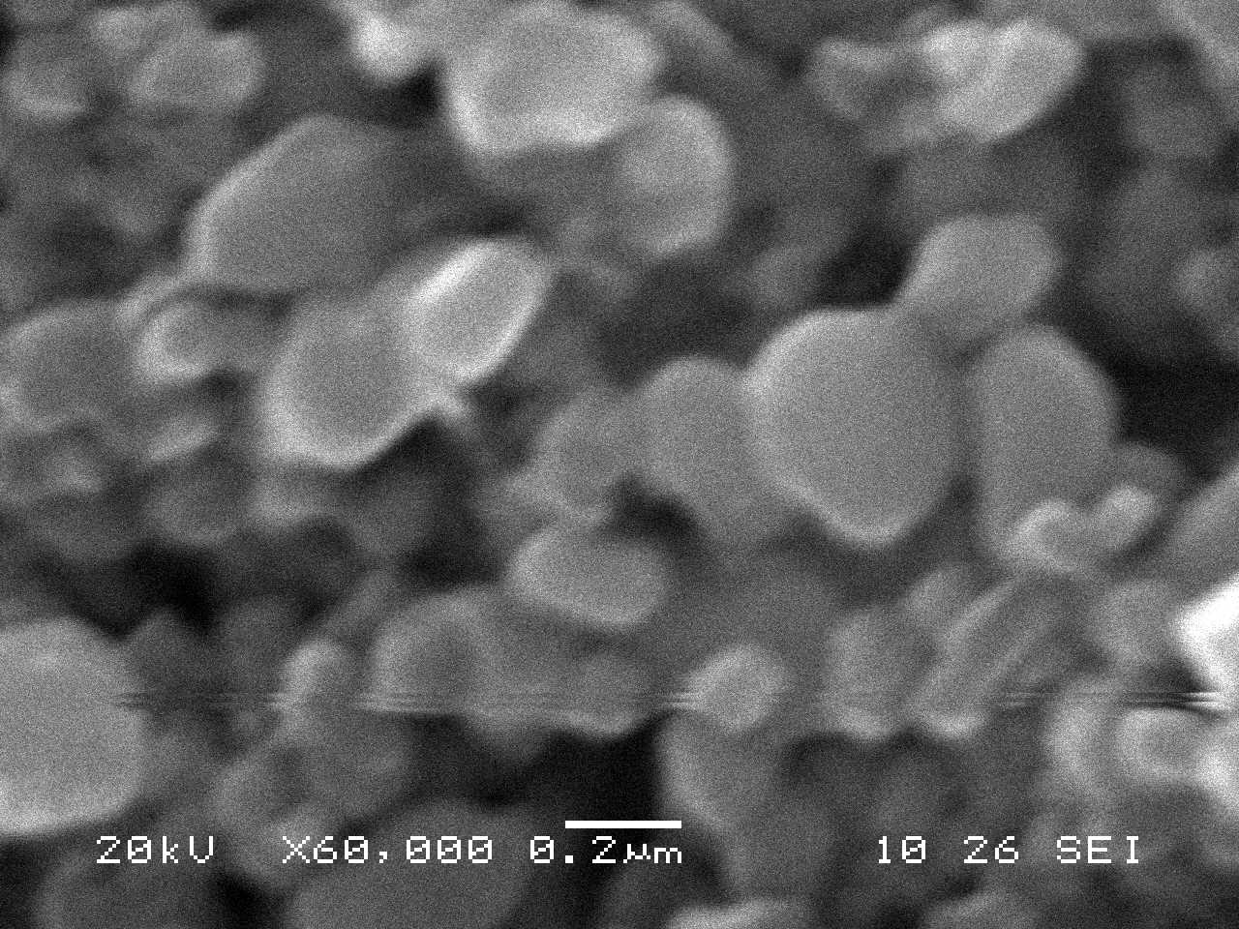

**Figure21: SEM images of TiO2 photo-anode at different magnification**

* **EDAX:-**



**Figure 22**:EDAX of TiO2 film

**Table 6 table to study EDAX**

|  |  |  |
| --- | --- | --- |
| **Element** | **Weight%** | **Atomic%** |
| **O k** | **69.64** | **87.29** |
| **Ti k** | **30.36** | **12.71** |
| **Total** | **100** |  |

**Conclusion:**

From the scanning electron Microscopy results we comes to know the granular morphology.And the TiO2  nanoparticles are poras.

* **JV charcteristics:-**

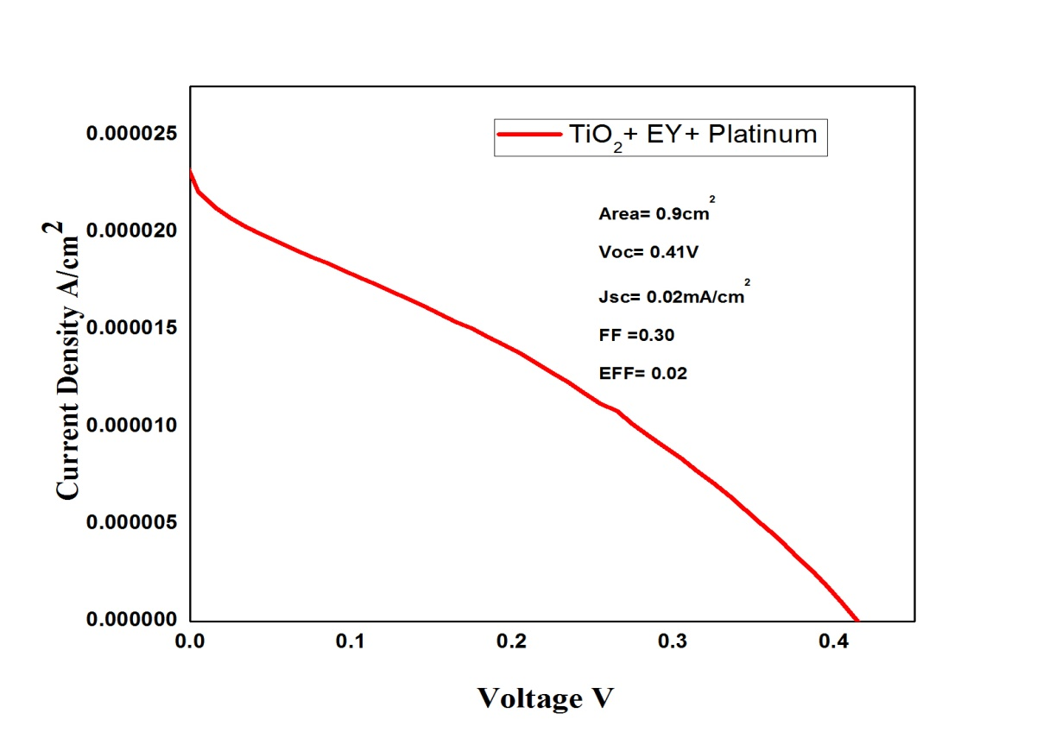

**Figure 23:** JV characteristics of TiO2based DSSC

**Conclusion:-**

As the devices is tested for some value of intensity of light.Here we use Eosin Y dye we get the efficiency 0.02%

* **Conclusions:-**
* We successfully made TiO2 photo anode via docter blade method.
* The crystal structure and phase analysis of TiO2 nanoparticles were crried out by using XRD.X-ray diffraction data reveals that at high temperature TiO2 nanocrystals are formed.
* We got the band gap energy of TiO2 is 2.017 eV.which is very nearly equal to standard value i.e 3.02 eV.
* JV characteristics suggests that a TiO2 based DSSC can be prepared in the labortary having quite good efficiency.
* **Future scope:-**
* Present work motivation to continue the research in nano synthesis via docter blade method.
* TiO2 nanocrystals may be useful for increasing the efficiency of dye sensitized solar cell.
* **References:-**

1. K.M. Lee,V.Suryanarayanan,K.C.Ho,Solar energy materials and Solar cells.
2. H.F. Wang,W.N.Su,B.J.Hwang,,P.C. Susumu Yoshikawa,Institute of advanced Energy,Kyoto University.
3. Basics of X-ray diffraction ,www.Scintag.com
4. Nanotechnology:Principles and practices, second edition by Sulabha K. Kulkarni.
5. Elements of X-ray Diffraction by B.D.Culity and S.D. Stock
6. ["Dye-Sensitized vs. Thin Film Solar Cells"](http://web.archive.org/web/20060210233608/http:/www.eifer.uni-karlsruhe.de/162.php), European Institute for Energy Research, 30 June 2006
7. Siegbahn. J. Photochem. Photobiol. A 148 **(**2002) 57.
8. Z. Chen, Y. Tang, L. Zhang L. Luo, Electrochim. Acta 51 **(**2006) 5870.
9. X. Cao, N. Wang, L. Wang, Guo L, J. Nanopart. Res. 12 **(**2010) 143.
10. J. X. Wang, C. M. L Wu., W. S. Cheung, L. B. Luo, Z. B. He, G. D. Yuan, W. J. Zhang, C. S. Lee, S.T Lee, J. Phys. Chem. C 114**(**2010) 13157.
11. M. Chen, Z. Wang , D. Han, F. Gu, G. Guo, J. Phys. Chem. C 115 **(**2011) 12763.
12. Z. Liu, Z. Jin, W. Li, X. Liu, J. Qiu, W. Wu, Mater. Lett. 60 **(**2006) 810.
13. P. K. Basu, S.K. Jana, M.K. Mitra, H. Saha and S. Basu, Sens. Lett. 6 **(**2008) 699.
14. P.K. Basu, E. Bontempi, S. Maji, H. Saha, S. Basu., J. Mater. Sci. Mater. Electron. 20 **(**2009) 1203.
15. H. Masuda, K. Fukuda, Science 268 **(**1995) 1466.
16. P.K. Basu , N. Saha , S. Maji , H. Saha, S. Basu, J. Mater. Sci.,Mater. Electron. 19 **(**2008) 493.